Huggy-Puppy Intervention (HPI & HPI-r) – For Parents
developed by Sadeh et al. (2007), Kushnir & Sadeh (2012); leaflet created by SIPE, EMDR Slovakia

Introduction
This intervention is aimed at reducing children´s stress and trauma related difficulties, such as anxiety, fears, startle response, nightmares, associated somatic problems etc. It´s directed at children cca 2-7 years old – the age when they can develop an attachment to a huggy-puppy doll.
For children of this age it is very important to rely on you – their caregivers. Your inner peace and kind soothing and care are the most precious interventions. You are their safe haven.
This simple playful technique can help your child feel more empowered and protected. This can increase the chance of positive coping, recovery and support resilience. It can also help you to feel more contented with your child´s ability to deal with the stressful situation.
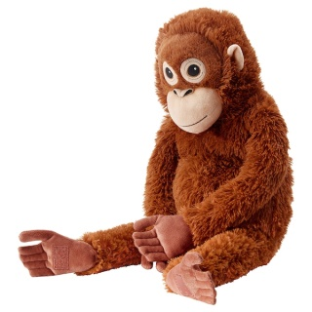
Your task is to encourage the child to use the huggy-puppy and not forget about it.
Here is the description of the intervention session which you attend together with your child.
This intervention can be used in two different versions which proved to be similarly efficient.

Intervention, HPI
During the intervention, your is introduced to a little Huggy-Puppy doll. He or she is told the following story. “This is my friend Huggy. Huggy is usually a very happy puppy. Right now, he looks a little sad and scared. Can you guess why he might be sad?” After your child replies, the story continues. “He is sad because he is very far away from his home and he does not have any good friends. He likes to be hugged a lot but he has no one to take care of him. Do you think you can be his good buddy, take care of him, hug him a lot, and take him to bed with you when you go to sleep?” Once your child agrees, the doll is given to him or her, with some demonstrations regarding how to hug and to be hugged by the doll.
After this presentation to your child, you will be is encouraged to maintain the child’s interest in the doll and to remind the child about his or her responsibility in caring for the puppy.

Revised version of the Intervention, HPI-r
„The revised version (HPI-r) ... is based on providing the same doll with a different cover story that is based on the notion that the doll would be the child’s friend and companion at night and would help the child in overcoming fears.“

Conclusion
No negative responses to this intervention have been reported. If any difficulties or unexpected reactions occur, please, contact us or another professional. In case of positive outcome, it might be useful to give us a feedback. If you feel that you are not able to provide a safe base for the child because you are too stressed yourself, please, ask for help. You are the child´s most important healing factor. The child needs you to be in as composed and stable as possible.

The Huggy-Puppy Intervention was first developed and used by the authors during the second Isreal-Lebanon war in 2006 for children 2-7 years old in a sheltered camp (1). The revised version was compared with the original one in a study of reducing nighttime fears in 2011 (2).

Sadeh, A. et al. (2007): Young Children´s Reactions to War-Related Stress: A Survey and Assessment of an Innovative Intervention. PEDIATRICS, 121(1).
Kushnir J., Sadeh, A. (2012): Assessment of brief intervention for nighttime fears in preschol children. Eur J Pediatr, 171.

